**Experiment name:**

I-V Characteristics of Diode

**Objectives**

We will study the I-V characteristic of the diode.

**Apparatus**

* 1🇽 p-n junction diode (1N4007)
* Resistor: 1🇽 1kΩ
* DC Power supply
* Digital Multimeter
* Chords and wires

**Theory:**

A diode is an electrical component that allows current to flow in a single direction. It converts alternating current (AC) to direct current (DC), regulates voltage, and controls current flow in electrical circuits. The device is bipolar, behaving as a short circuit in forward bias and an open circuit in reverse bias**.**

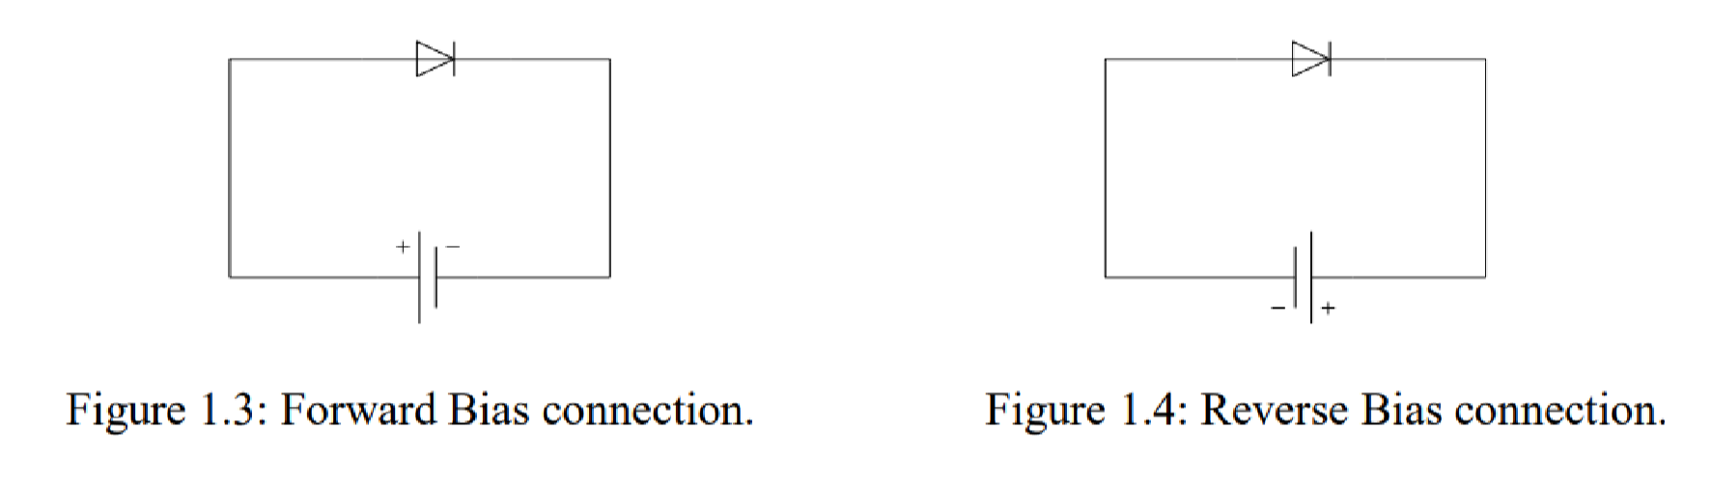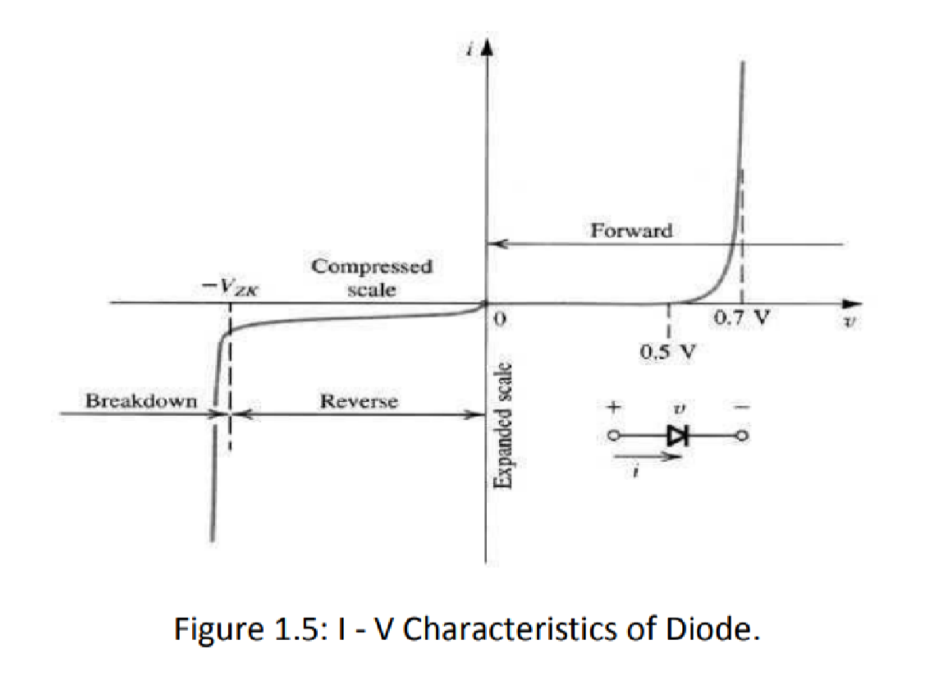

From the graph we can see that there are two types of biasing conditions for a diode:

**Forward bias:** If a diode is connected to a voltage source with positive polarity on the P side (anode) and negative polarity on the N side (cathode), then it is in a forward bias condition. In this condition, the depletion region of the diode shrinks, decreasing the resistance and allowing current to flow easily through the diode.

The characteristics curve shows that a specific forward bias voltage (VT) is needed to reach the region of the upward swing. This value, VT, is known as the diode's cut-in or threshold voltage. The normal threshold voltage for Si diodes is 0.7 volts, whereas for Ge diodes it is 0.3 volts.

**Reverse bias:** If a diode is connected to a voltage source with positive polarity on the N side and negative polarity on the P side, then it is in a reverse bias condition. In this condition, The depletion region expands, increasing the resistance and preventing current flow through the diode. Only a very small leakage current flows (at the microampere range).

However, if the voltage continuously increases in the reverse direction, at a certain value the diode will break down and a huge amount of current will flow in the reverse direction. This is called the breakdown of the diode unless it's a special type like a Zener diode.

**Circuit Diagram:**

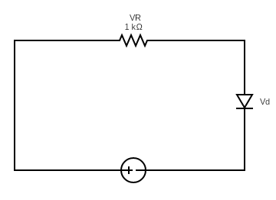

**Experimental Procedure:**

1. First, we accurately measured the resistance of the 1kΩ resistor using a digital multimeter (DMM), ensuring the correct value.

2. Afterward, we built the circuit as shown in Figure 1.6, using the 1kΩ resistor and a 1N4007 diode.

3. We then varied the input voltage (Vac) based on the values provided in the table.

4. For each increment of input voltage, we measured Vac (the input voltage), the voltage at point A (Va), and the voltage across the resistor (VR), recording all values in a data table.

5. We continued to increase Vac until we obtained the maximum value of Va, ensuring that the input voltage (Vdc) did not exceed 25V.

6. Finally, we calculated the current (Id) for each measurement using the formula Id = VR / R (in mA), where VR is the voltage across the resistor.

**Results:**

| **Vdc(volt)** | **0.1** | **0.3** | **0.5** | **0.7** | **1** | **2** | **3** | **4** | **6** | **8** | **10** |
| --- | --- | --- | --- | --- | --- | --- | --- | --- | --- | --- | --- |
| **Vd(volt)** | 0.099 | 0.3 | 0.457 | 0.512 | 0.559 | 0.614 | 0.640 | 0.656 | 0.675 | 0.69 | 0.69 |
| **VR(volt)** | 0 | 0.0009 | 0.05 | 0.175 | 0.443 | 1.376 | 2.35 | 3.343 | 5.317 | 7.31 | 9.29 |
| **Id = (mA)** | 0 | 9.184✕10-4 | 0.051 | 0.17857 | 0.452 | 1.4041 | 2.4 | 3.411 | 5.43 | 7.46 | 9.48 |

From the obtained values from the experiment, we can find three observations:

**i)** The voltage measured across the diode does not exceed 0.7V i.e. Vd 7V. It is because we have used the **silicon diode** of which the **threshold voltage is 0.7V**. Therefore, the voltage measured across the diode rises at first but becomes slow as it approaches near 0.7V.

**ii)** We can also see **KVL(Kirchhoff’s Voltage Law)** in the circuit, i.e. Voltage rise = Voltage drop. Here, **Vdc Vd + VR**. For instance, when Vdc is applied at 0.5 volts, Vd and VR are found to be 0.457 volts and 0.05 volts, respectively, which sums up to approximately 0.5 volts as Vdc.

**iii)** Another interesting thing we can observe from the results is the circuit following **Ohm’s law**. As the voltage Vdc increases, the current flowing through the diode Id also increases. This clearly shows that the circuit follows the principle of Ohm’s law.

**Questions and Answers:**

**1. Taking readings from the data table, draw curve of diode in a graph paper with**

**proper scale [x-axis: 0.2 V per unit, y-axis: any suitable range].**

**Ans:**

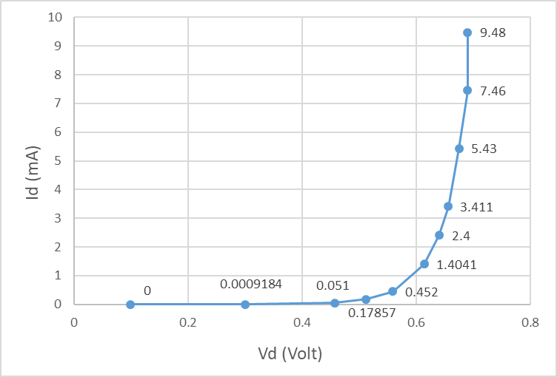

**2. What is the dynamic and static resistance of a diode?**

**Ans:** The resistance offered by the diode when AC is applied to the diode is called AC resistance or dynamic resistance. The current flows in both directions when AC voltage is applied. The ratio of change in voltage to change in current represents the dynamic resistance of

the diode. It is denoted by Rac. Rac =

When DC is fed to the diode, the current flows in one direction. The resistance offered

by the diode is called the DC resistance.

**3. From the graph, find Vd for corresponding values of Id = 5 mA and Id = 10 mA and**

**calculate the static resistance.**

**Ans:**

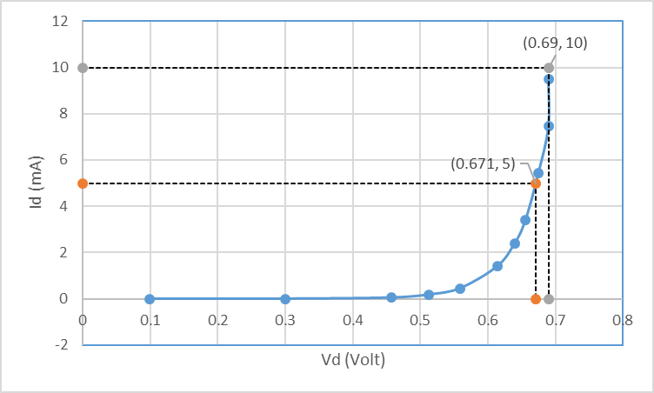

From the graph, we can see that,

­V­d = 0.671 V when, I­­d = 5 mA

and,

­V­d = 0.69 V when, I­­d = 10 mA

For I­­d = 5 mA,

The static resistance, R = $\frac{V_{d}}{I_{d}}$ = $\frac{0.671 }{5×{10}^{-3}}$ = 134.2 Ω

For I­­d = 5 mA,

The static resistance, R = $\frac{V_{d}}{I_{d}}$ = $\frac{0.69 }{10×{10}^{-3}}$ = 69 Ω

**4. Considering Vdc = 2 volt, find the load line (Showing all calculations)**

**Ans:**

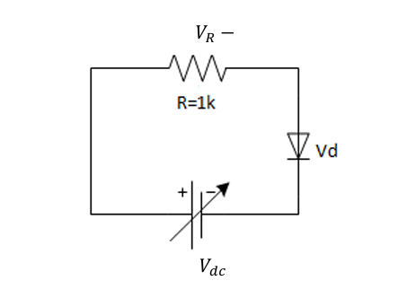

If Vdc = 2V, then applying KVL to the circuit,

-2 + VR + VD = 0

$⇒$-2 + 1000ID + VD = 0

$⇒$ VD + 1000ID = 2

$⇒$ $\frac{V_{D}}{2}+500I_{D}=1$

$⇒$ $\frac{V_{D}}{2}+\frac{I_{D}}{\frac{1}{500}}=1$

Therefore, the load line equation is $\frac{V_{D}}{2}+\frac{I_{D}}{\frac{1}{500}}=1$, which implies if VD = 0, ID = A = 2 mA, and if ID = 0, VD = 2 volts.

**5. Draw the load line in the curve of diode and find Q-point.**

**Ans:** From (4) we get, the load line equation is $\frac{V_{D}}{2}+\frac{I_{D}}{\frac{1}{500}}=1$, which implies if VD = 0, ID = A = 2 mA, and if ID = 0, VD = 2 volts. Plotting the two points (0, 2) and (2,0) on the graph and joining them we get,

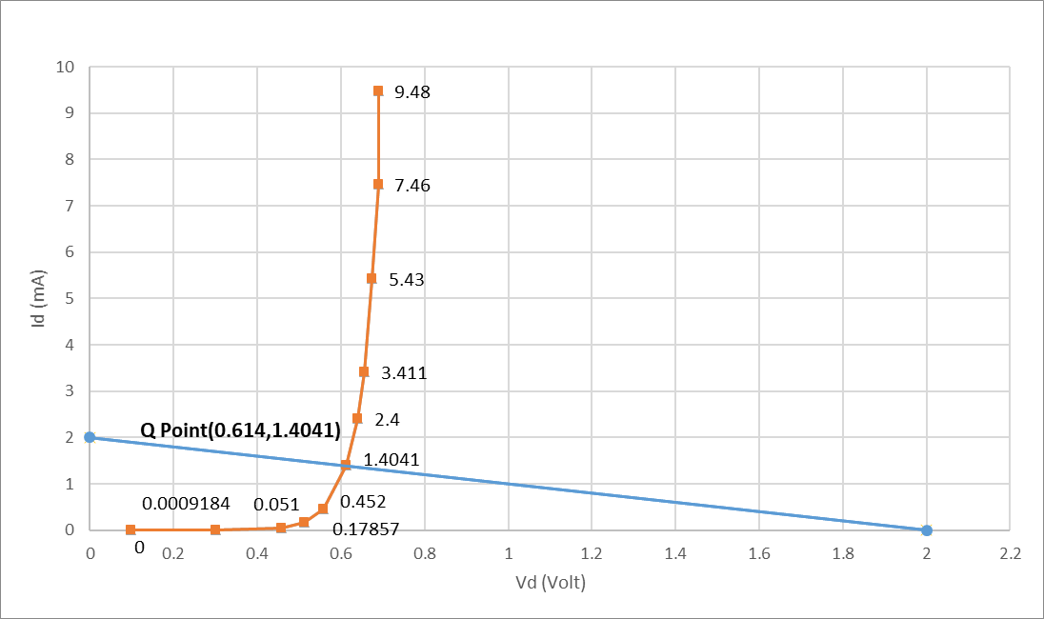

So, drawing the load line on the diode curve, the Q-point is (0.614, 1,4041) i.e. 0.614 volts and 1.4041 mA current.

**Discussion:**

In this experiment, we observed the current voltage (I-V) characteristics of a diode under forward bias conditions. At first, we used a DMM to identify the anode and cathode of the diode and then connected the anode with the positive polarity of the voltage source and the cathode to the negative polarity. At 0.1V, the voltage across the resistor is 0, and the current is also almost 0. From 0.1 – 0.5V, we observed low and unstable current readings. This was likely due to insufficient voltage to overcome the threshold. After 0.7V we observed a rapid increase in the current. According to the readings we took from the experiment, we can say the threshold voltage of the diode used is 0.7V which is the same as the threshold voltage of a silicon diode. This experiment demonstrated that in forward bias, After reaching the threshold voltage, the diode began to conduct strongly, following an exponential increase in current. The results supported theoretical expectations, proving the diode's behavior as a one-way current conductor.

**Simulation:**

